

**Computer Science Department**

**COMP133 ( Spring 2020 )**

**Project Phase Two *Due Date: Mon (11/5/2020) by 10:00 pm (on Ritaj)***

In this phase, ***you first need to define:***

***1-constant called MAXSIZE ( max number of books stored) equal to 100.***

***2- global variable called size =0 ( current number of books stored )***

The main function should define three arrays:

***int bins[MAXSIZE] ;***

***double prices[MAXSIZE];***

***int status[MAXSIZE];***

you now need to implement the major parts of the functions you created in phase one as follows:

***void displayMainMenu();*** // displays the main menu shown above

This function will remain similar to that in phase one with one minor addition which is the option:

***4- Print Book List*** which calls the function ***printBooks(…)***

***void uploadDataFile ( int bins[], double prices[],int status[]);***

This function will receive the arrays containing the bin (***id***) numbers and the prices as parameters. The function will open a file called ***books.txt*** for reading and will read all the book bin numbers and prices and store them in the arrays. For each book info added you should enter the value 1 (one) in the status array. The global variable ***size*** should be set to the number of books read from the file and stored in the array.

***void addBook( int bins[], double pri ces[],int status[]);***

This function will receive the arrays containing the bin numbers and the prices, and the status as parameters.

The function will check to see if the list is not full. If list is not full ( size < MAXSIZE) then it ask the use to enter a bin number and a price and will have one of three choices:

1. if the bin number is already in the list ( the book with that bin exists and the status = 1) it will display an error message (“book already exists”).
2. If the bin number does not exist, the function will add the book’s bin and price to the end ( at index ***size*** ) of the bins and prices arrays and will put a 1 in the status array. The global variable ***size*** should be incremented (***size++).***
3. ***If the book with that bin already exists but the status is 0 then change the status to 1 and size is not incremented.***

***void removeBook(int bins[], double prices[], int status[]);***

This function will receive the arrays containing the bin numbers, the prices, and the status as parameters. The function will check if the list is not empty. If it is not empty (size > 0) then it will search for the bin number to be removed and if not found will display an error message. If the bin number exists and the status number is 1, the function will remove it by simply changing the status value from 1 to 0 and ***size*** remains the same.

***void searchForBook(int bins[], double prices[], int status[]);***

This function will receive the arrays containing the bin numbers, the prices and the status as parameters. The function will check if the list is not empty. If it is not empty (size > 0) then it will ask the user to enter a bin number and will search for that bin number. If the bin number is not found ***( or is found but the status is 0*** ), it will display an error message.

If the bin number is found ( and the status is 1 ) then it will be displayed along with the price in a suitable format on the screen.

***void updateDataFile(int bins[], double prices[], int status[]);***

This function will receive the arrays containing the bin numbers, the prices, and the status, as parameters. The function will open the file called ***books.txt*** for writing and will write to that file the bin number and price of each book in the array that has a status value of 1 is the status array.

***void printBooks (int bins[], double prices[], int status); // NEW FUNCTION***

This function will receive the arrays containing the bin numbers , the prices and the status as parameters. This function will print the information (bins and prices) currently stored in the arrays that have a status of 1 in the status array.

**Items that should be turned in by each student:**

1. ***A copy of your program code.***
2. ***An image file of a complete run similar to the output shown on page 3.***

***( To do this you can PrintScreen when you run your program and then paste into the paint program and then save it as an image file )***

1. Turn in your project phase by ***replying to the course coordinator’s message*** on Ritaj and attaching both your code file + run image file.
2. **Your name and id number should be included in the code file as a comment.**

***SAMPLE RUN:***

Make sure your program works **very similar** to the following sample run:

***Assuming that at the beginning of the run file books.txt has the following information stored:***

1234 72.45

2345 25.20

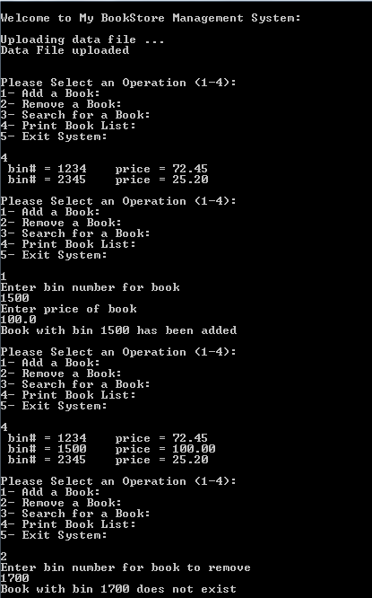

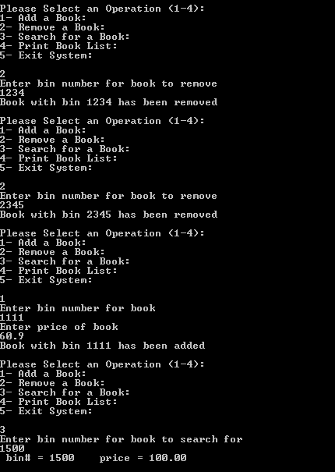

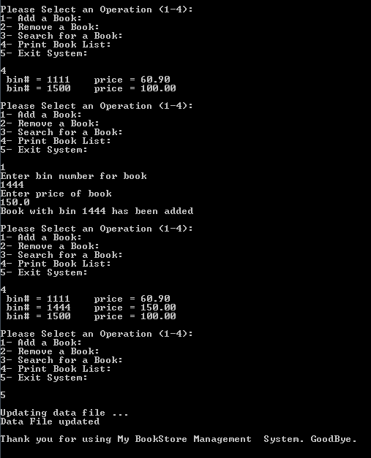

***Late project phases will not be accepted for any reason***.